Edison Replacement LED Board Assembly Instructions:

1. Prerequisites

The project will require certain skills and tools. Primarily this project involves some SMD soldering. None of the parts are tiny by SMD standards (1206 is as small as it gets), but you will still want to have had some success soldering in the past or a good soldering mentor to help. Magnification will also be very helpful to check your work and determine the polarity on the LED.

Tools you will NEED:

* Temperature controlled soldering iron with a moderately small tip
* Solder (Flux is nice to have as well)
* Tweezers / Needle Nose Pliers
* Wire stripper for small wire ~30 gauge
* Diagonal Cutters
* #1 Philips Screwdriver
* Heat Gun (helpful but not required)

1. Included Parts

The following parts should be included in your kit. Should something go wrong feel free to see me as I may have extra parts.

* 1x Bare PCB

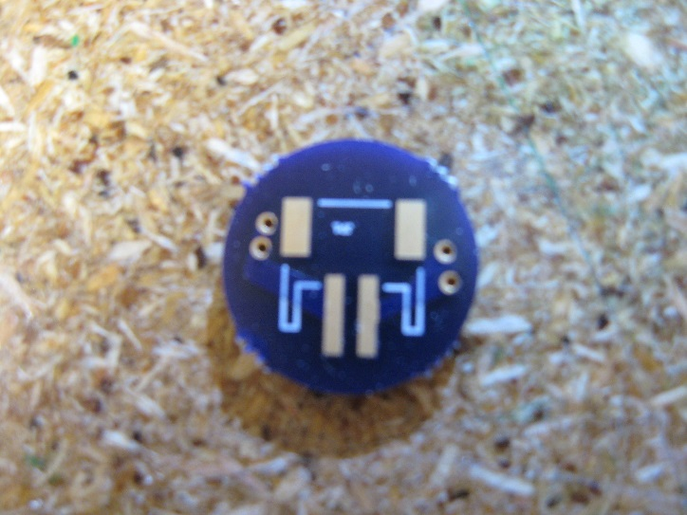 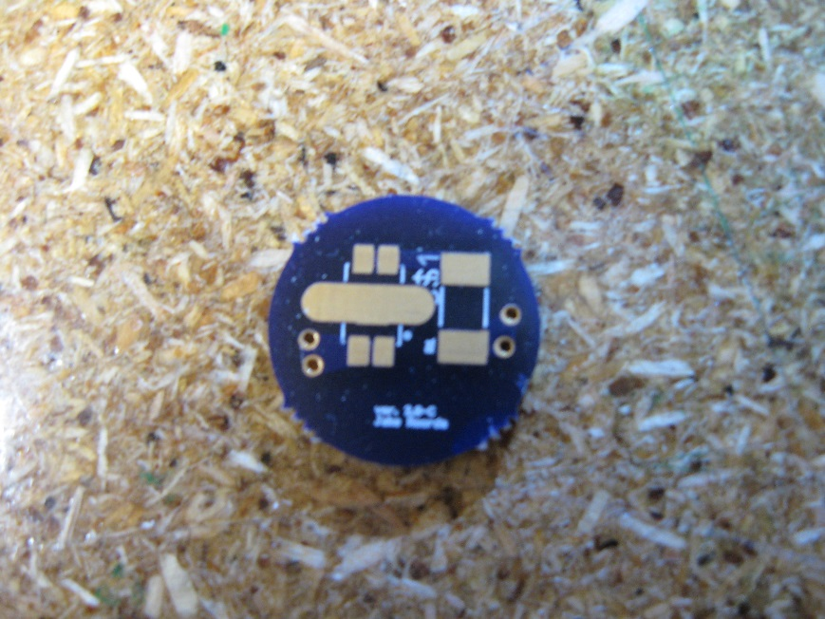

Board Front

Board Back

* 1x 16 ohm resistor
* 1x White LED
* 1x JST2 Pigtail Cable
* 1x JST2 SMD Jack
* 1x small zip-tie
* 2x small pieces of heat shrink tubing.

1. Solder the LED to the PCB

The SMD LED is the core of the project and should be soldered before the resistor to allow for iron clearance. The LED will come in a piece of cut strip. If you have magnification now is the time to use it to look at the LED. Note that it has four pins on its exterior and one pad in the middle of the part. The middle pad is used for thermal conduction while the other four pins are the anode and the cathode. The pins on each end are shorted together, so the current flows through the part along its long axis.

Start the assembly process by tinning (placing a thin layer of solder over the copper) the middle of the large thermal copper pad on the board.

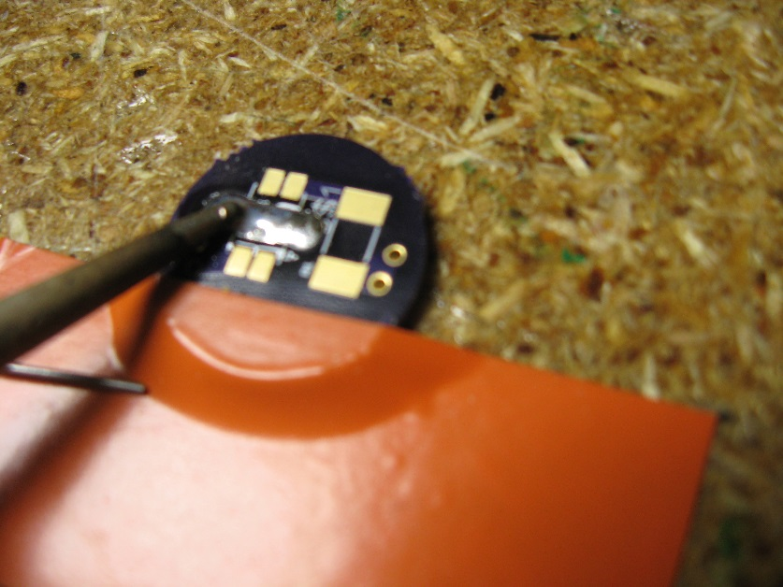

Lay the LED on its footprint and apply heat to one side of the thermal pad until the solder melts and the LED sinks down onto the pad. **Note:** The LED must be put in the right direction! One corner of the LED package is clipped. (See the following picture) This side corresponds to the dot on the PCB silkscreen and is the (–) size of the LED. You can also check this with the diode function of a good DMM.

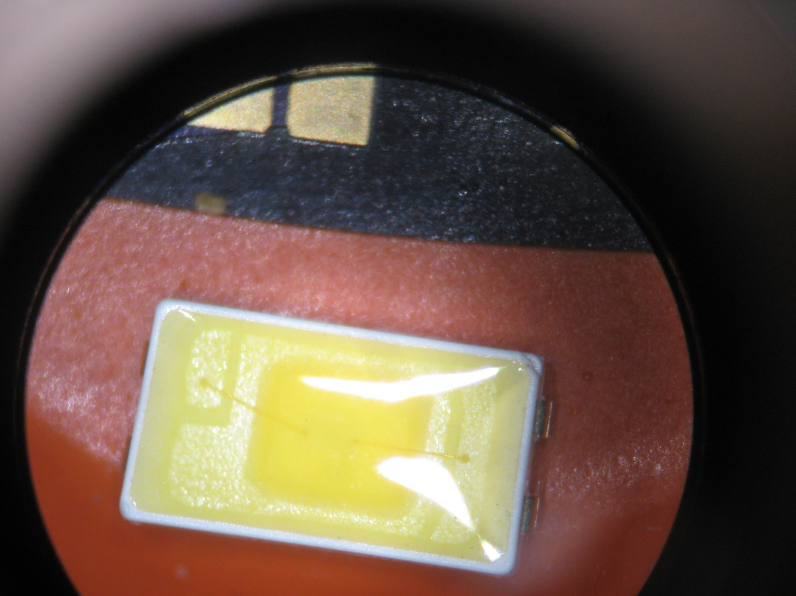

+

-

-

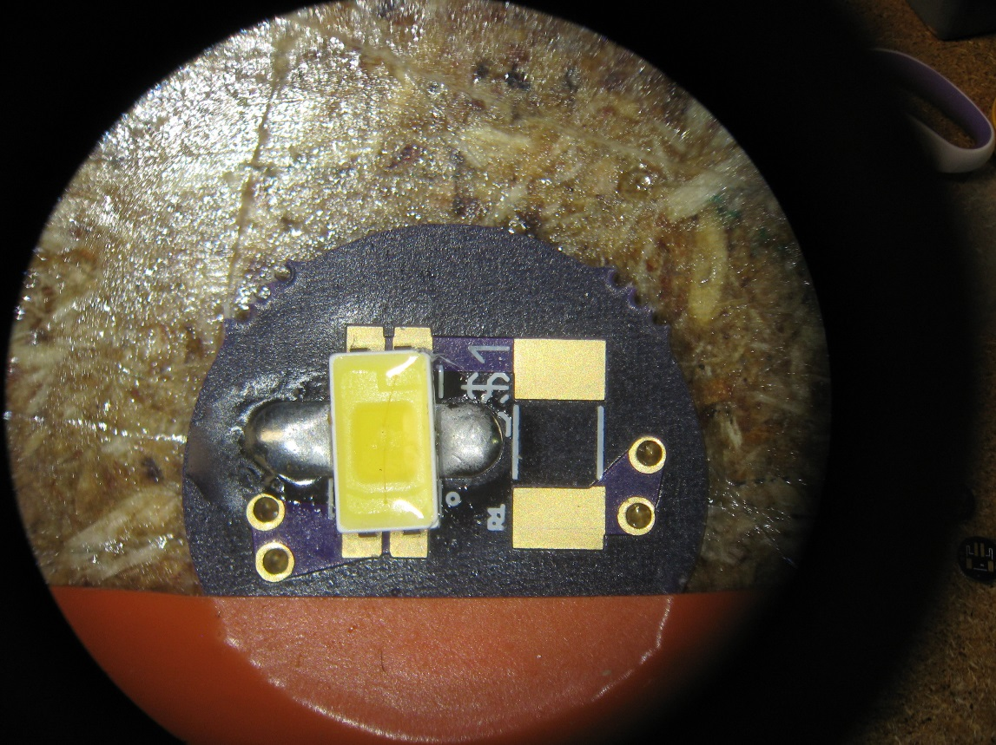

With the LED affixed to the board, solder the other 4 leads to their pads. It is important to do this last so that a good thermal contact is made to the bottom of the LED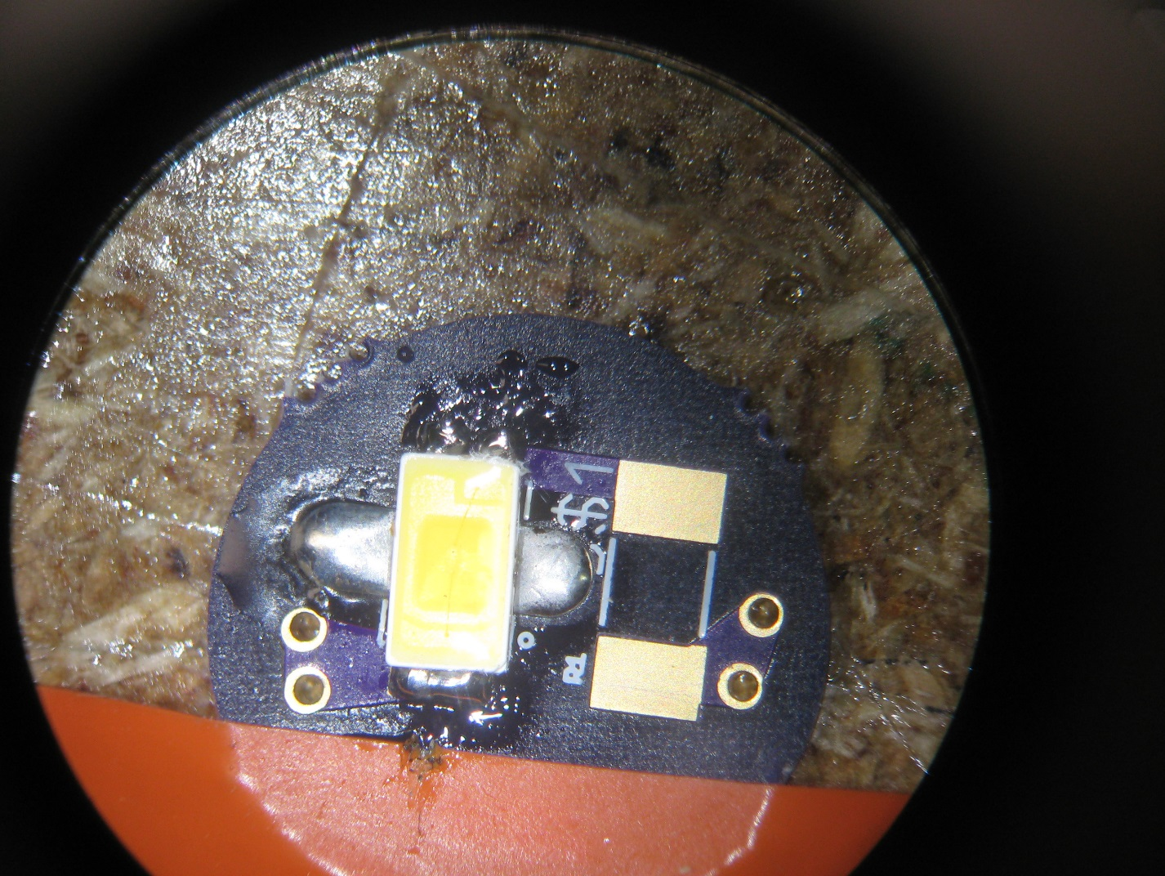

1. Solder the resistor to the PCB.

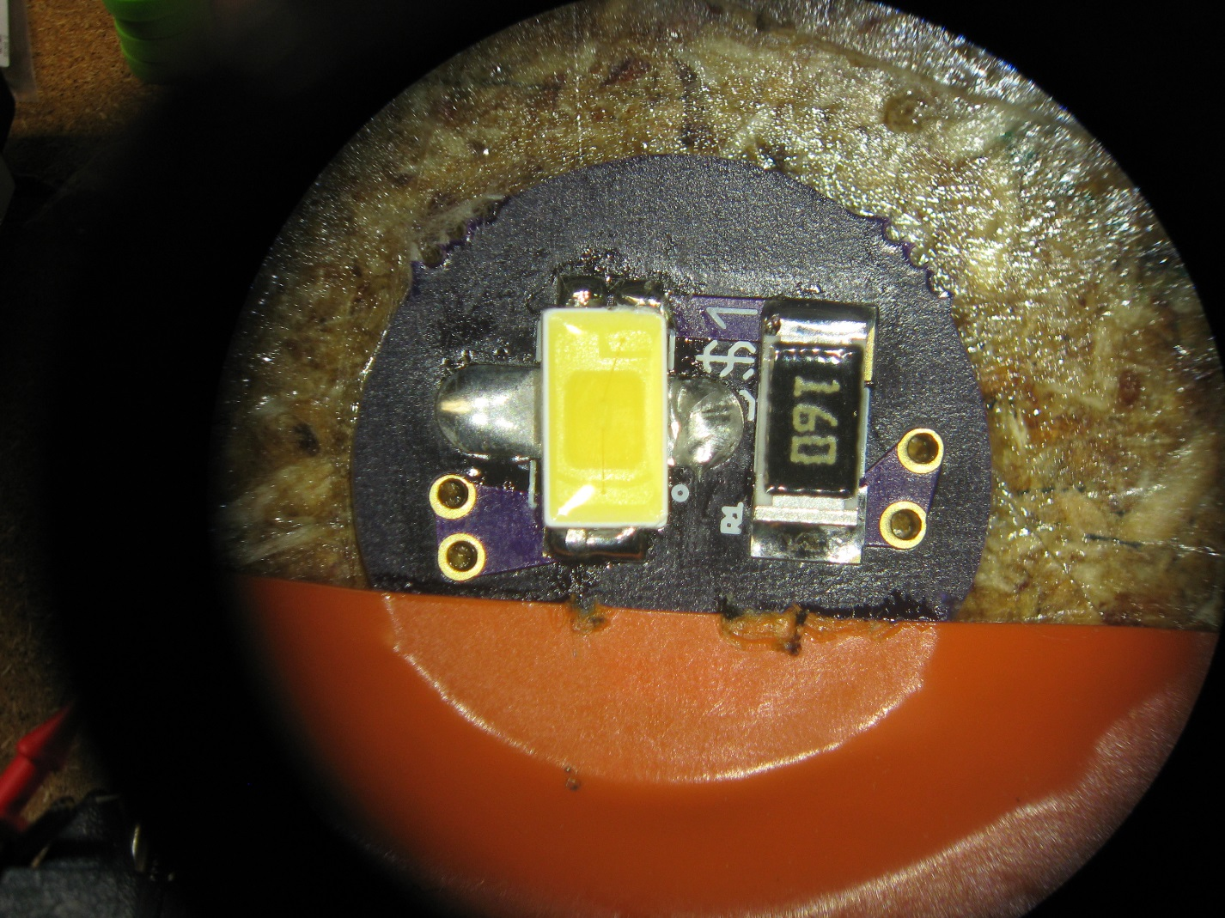

1. Solder the JST2 jack to the back side of the PCB. The two pins in the rear of the connector are for the power while the two pads on the front of the jack are for support. The connector will see a fair amount of stress of connector insertion, so all of the pads should be soldered well. 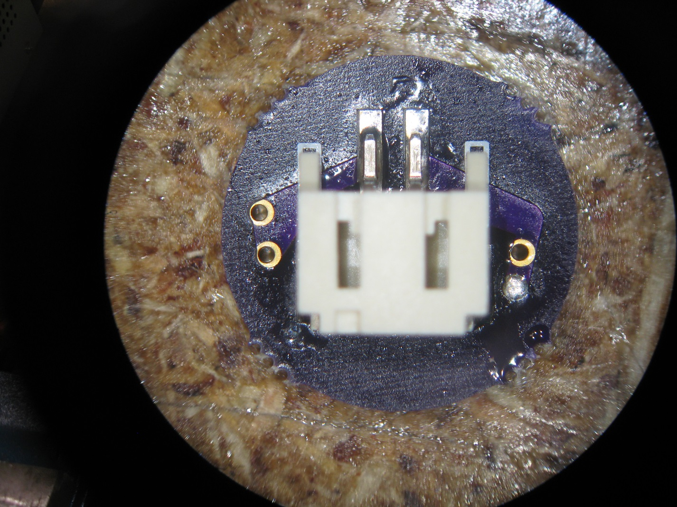
2. Setting the PCB aside, remove the top of your light bulb by removing the small Philips screw and then unscrewing the top like a normal light bulb.
3. To make the conversion the old LED has to go. Using a diagonal cutter first cut of the two wires leaving as much of each connected to the base as possible. Cut the resistor off of the wire it is connected to, saving as much of the wire as possible. Finally remove the LED by cutting the lead right above where it is crimped to a metal holder. **Make sure you don’t remove the metal piece that holds the LED.** It is needed to hold the new board.
4. Connect the JST pigtail connector to the previously severed wires. Tin each wire before soldering them together and use the provided heat shrink tubing to insulate the joints. The Red JST wire should mate to the TBD light bulb wire while the black JST wire should mate to the TBD light bulb wire.
5. Plug in the LED and position it so it lights the top of the bulb (see the photo). It is held in place by zip-tying the connector wire to the metal support that was previously crimped to the old led.
6. The connector wires should hold their shape reasonably well. Tuck the wires into the base of the bulb and adjust the orientation of the board until the light looks good with the top screwed on. This may take some time and practice depending on how much of a perfectionist you are.
7. Presuming you haven’t lost it, replace the tiny screw and bask in the new, brighter light.